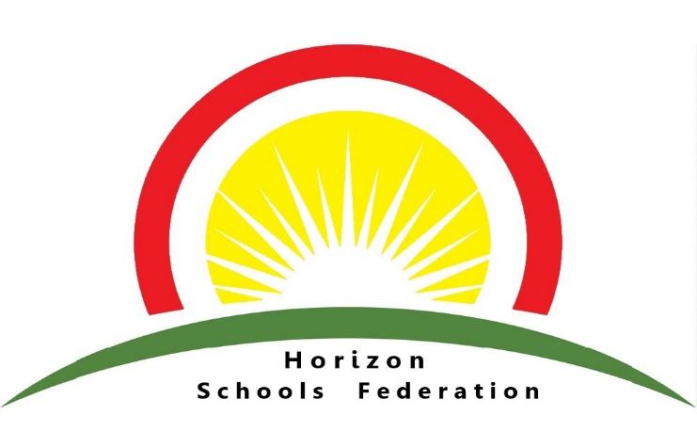

Midday Supervisory Assistant

Donington Cowley Endowed Primary School
Hours: 7.5 hours a week, 38 weeks per year
Salary: Grade 2, SCP 3 (£24,413 - £25,989 pro rata)
Start Date – 1st September 2026
An exciting opportunity has arisen for a Midday Supervisory Assistant to join our team at Donington Cowley Endowed Primary School. We are looking for someone to join our lunchtime team to ensure smooth running of our lunchtime supervision. You will be required to complete Basic Food Hygiene training along with safeguarding training.

In return our school offers a welcoming, safe, happy learning environment where everyone is respected and listened to; a school where we take pride in ourselves and our achievements, enabling children to become confident and successful learners. We recognise the value of each individual and provide a wealth of opportunities for children to realise their potential. We work in partnership with pupils, governors, the local and wider community to encourage children to strive for excellence and aim high, laying the foundations for life-long learning.

Main duties and responsibilities:
- Serving of food at lunchtime
- Maintaining a high level of hygiene
- Cleaning the hall at the end of the lunch period
- Support and supervise the children over lunchtimes

Closing Date: Thursday 18th June
Interview Date: TBC
Please contact Sarah.Bach@cowley.lincs.sch.uk if you wish to discuss this role further or would like an application pack.
Horizon Schools Federation is committed to safeguarding and promoting the welfare of children and young people and expects all staff and volunteers to share this commitment. Applicants should note that this post is subject to enhanced DBS disclosure. Pre-employment checks are in line with Keeping Children Safe in Education 2025.
All shortlisted candidates will need to verify their eligibility to work in the UK at interview.
Please note that we are unable to accept a CV as an application.

