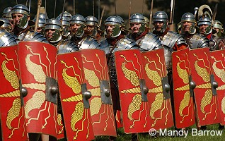

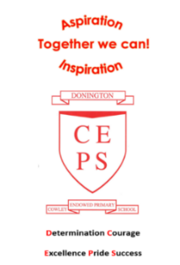
Invasion!
Maths
Maths will be taught as an individual subject and will continue to adhere to the curriculum objectives. Teaching will enable children to become fluent in arithmetic as well as being able to reason and problem solve. Our Maths lessons in the autumn term will focus on Place Value and Addition and Subtraction. We will also begin to look at Multiplication and Division. Pupils will be extended at every opportunity to ensure their potential as mathematicians is achieved.
Take home task to support work in school
To prepare for our new topic, it would be brilliant if the children could find some fascinating facts about the Romans, Anglo-Saxons, or Vikings. This could include daily life or religion and beliefs or anything else about any of the time periods of your choice! These can be presented in a medium of their choice – a model would be especially good! They will need to be prepared to present and talk about their work to the rest of the class.
More about our topic…
We will begin the term with an in-depth study of Life through a Lincolnshire Lens for two weeks, focusing on the geography of Lincolnshire. We hope to inspire the children’s curiosity about our local area and county.
Our main topic for the rest of the autumn term will be Invasion! We shall gain knowledge of why the Romans, Anglo-Saxons and Vikings invaded and settled in Britain. The children will develop understanding of what daily life was like in each of these periods in time. We will then use our knowledge to compare life in each period and decide when we would have preferred to live and why.
In addition to this, we will be using different sources of evidence to collect information and build our understanding of the past. When looking at sources of evidence, we will begin to think about why there may be different accounts of history. Our main focus will be on the importance and effect each period has had on modern Britain.
This is an incredibly fascinating topic, and we aim to make it a memorable one! Through cross-curricular learning we will partake in some exciting activities. Make sure you continue to keep an eye on our web pages to see the fantastic learning taking place!

Squirrels, Moles, and Badgers Autumn Term 2025
English
Our class text for the autumn term will be How to Train your Dragon by Cressida Cowell. It is set in a fictional Viking world and focuses on the experiences of protagonist Hiccup Horrendous Haddock the Third, as he overcomes obstacles on his journey of "becoming a hero, the hard way".
In Year 3 / 4, Reading for pleasure and enjoyment lies at the heart of our English curriculum. Children will be involved in guided reading, using a wide range of texts, linked to our topic. They will take part in group discussions and will be encouraged to share their own views and reading interests. Through discussion and questioning comprehension skills will be developed, enabling children to increase understanding and appreciation of literature.
Children will have the opportunity to research and write their own chronological reports based on Lincolnshire as well as use their writing skills to write stories from other cultures, newspapers and poems linked to our history work.
Opportunities within all areas of the curriculum will be made available for children to develop their spoken language through discussion, drama, and presentations.
Science
In Science this term, we will be initially looking at ‘Plants and living things’ Through this unit, we will be focusing on the requirements of plants and animals for life and growth. We will also Investigate ways our skeleton and muscles work.

